Pat Birkeland

06/11/2021

Foundations of Programming: Python

Assignment 6

Apply Your Knowledge: Week 6

# Introduction

This activity will demonstrate working with functions and a simple class within a script which will modify a file named **ToDoFile.txt**.

A follow on activity will involve posting work to a GitHub repository that includes a GitHub web page.

# Modify Assignment06_Starter.py File

Step 5 of this assignment asked that we start our work with the **Assignment06_Starter.py** file. I modified the name of this file to **Assignment06.py** after listening to the instruction in the *Assignment 06 Review* video.

At the completion of this assignment the below functions had been written.

* Processor.read_data_from_file(strFileName, lstTable)
* Processor.add_data_to_list(strTask, strPriority, lstTable)
* Processor.remove_data_from_list(strTask, lstTable)
* Processor.write_data_to_file(strFileName, lstTable)
* IO.input_new_task_and_priority()
* IO.input_task_to_remove()

I was able to confirm successful execution of the below actions.

* Load data in a file (ToDoFile.txt) into a list
* Write list data to a file (ToDoFile.txt)
* Add rows to a list
* Remove items from the list
* Reload a current list with data from a file (ToDoFile.txt)

# Run Your Script

Step 5 asks that the saved script be executed from an OS shell window (Figure 1).

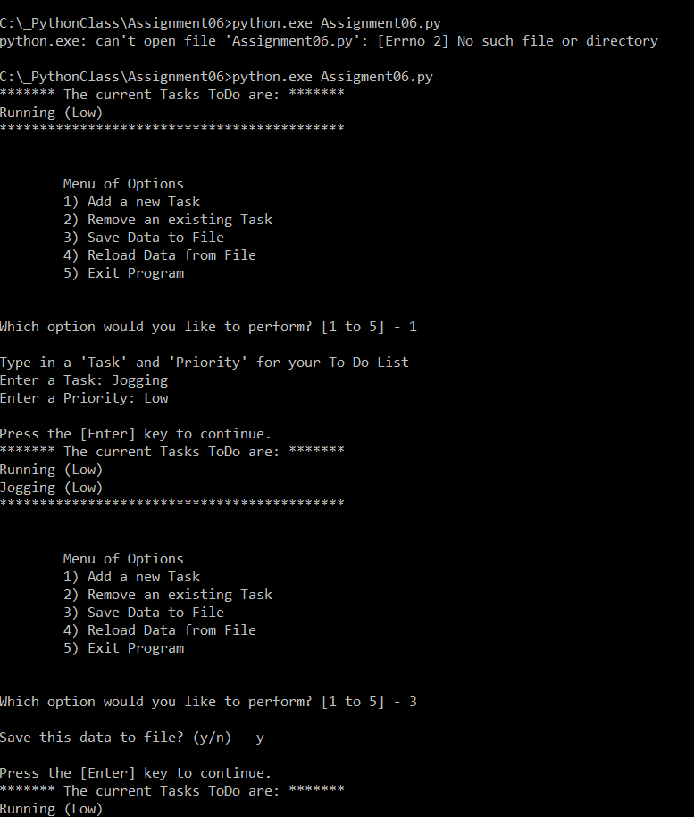

***Figure 1: The results of running Assignment06.py from a command shell***

Step 5 also asks that the saved script executes successfully PyCharm (Figure 2).

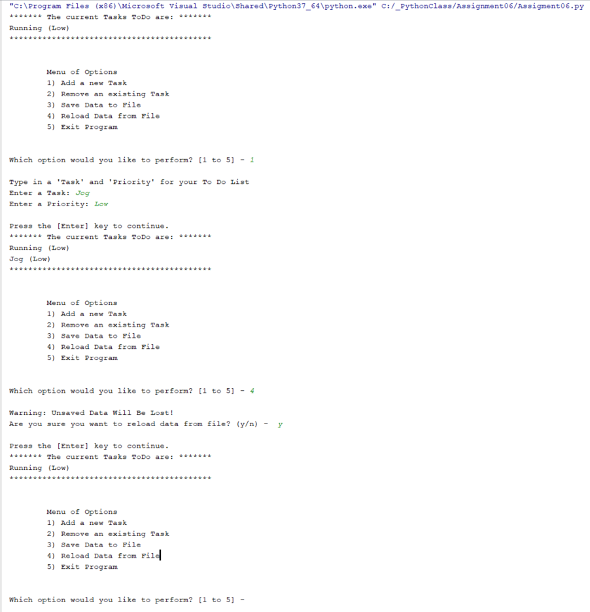

***Figure 2: The results of running Assignment06.py from PyCharm***

# Verify the Script Worked

Below is a screen capture showing the text file **ToDoFile.txt** exists and has been updated from the program interface. (Figure 3).

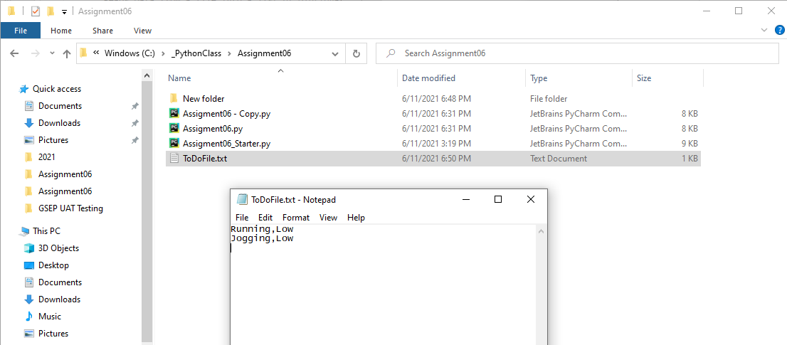

***Figure 3: Contents of the target file – ToDoFile.txt***

# Create a GitHub WebPage

Below is a screen capture showing that I have created a GitHub webpage. The page can be accessed at https://x10339966.github.io/ITFund100-Mod06/ (Figure 4).

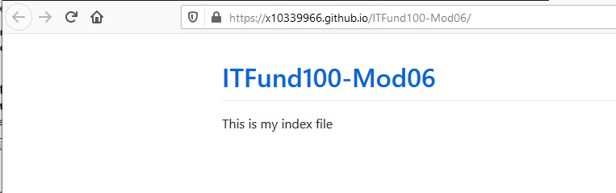

***Figure 4: Screenshot of GitHub WebPage***

# Upload Week 6 Deliverables to GitHub

I created a repository named **x10339966/IntroToProg-Python-Mod06** as instructed and uploaded my Word document and .py file as seen in the screen shot below (Figure 5). Please note the Word document is not in this screen shot as it was taken before the Word doc was uploaded.

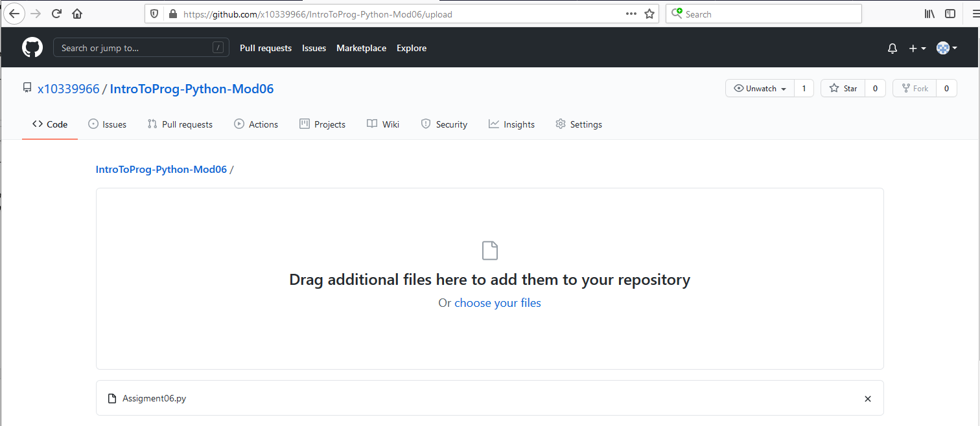

***Figure 5: Screenshot of GitHub Repository Upload***

# Summary

In this assignment we:

* Created a program using functions
* Created a GitHub Web Page
* Uploaded week 6 deliverables to GitHub